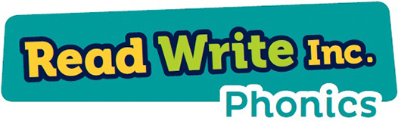

PARENTS OF EYFS, YEAR 1 AND YEAR 2

Read Write Inc. Learning at home

Daily virtual lessons for children:

From Monday 23rd March we’re scheduling Read Write Inc. Phonics lessons on Facebook and YouTube for children to watch at home.
We will release three short Speed Sound lessons with one of our trainers every day for the next two weeks. The films will only be available at the times below:
- Set 1 Speed Sounds at 9.30 am and again at 12.30 pm
- Set 2 Speed Sounds at 10.00 am and again at 1.00 pm
- Set 3 Speed Sounds at 10.30 am and again at 1.30 pm
Please note: the films are streamed live and won’t be available at other times.
We’re also releasing a film of a poem for Reception and Year 1 children to join in with at 2.00 pm every day. The poems will be available on YouTube to watch again and again.
A great opportunity for children to learn these by heart!

Films for parents
Films for parents to help their child learn to read at home with Read Write Inc. Phonics are available on our website and YouTube channel. The YouTube channel will have a quick face-lift to help parents find the films easily. We’re adding a parent film to Facebook every day too

